# Annie Ng

# Feb. 27, 2020

# Foundations of Programming: Python

# Assignment06

Creating Scripts Using Functions in PyCharm

# **Introduction**

In this assignment, I will show the steps on creating a script using functions and classes. This assignment shows the separation of concerns in programming, which means the script is divided into sections, so that each section addresses a separate concern (Root, Randal. _Mod5PythonProgrammingNotes.pdf. p.10). With the separation of concerns we will see the three sections of data, processing, and (input/out) presentation when we run the functions in the script. Writing the script with separation of concerns and functions also helps to organize the code when they become more complex.

## **Functions**

“Functions are a way of grouping one or more statements. In Python, you must define a function before you can use the code to call the function. Calling the function executes the statements in the function” (Root, Randal. _Mod6PythonProgrammingNotes.pdf. p.2). In Assignment06 the functions are defined in the processing and presentation sections and are executed in the “Main Body of the Script”.

## **Parameters**

Parameters are description of the job that functions are performing. “These allow you to pass values into the function for processing. Values passed into parameters are called arguments” (Root, Randal. _Mod6PythonProgrammingNotes.pdf. p.2). The Assignment06_Starter.py file has the parameters set already.

## **Pseudo-Code**

The pseudo-code we will use is the Assignment06_Starter.py.

## **#Data**

For the program to start and load any data from a text file we must create the text file with data in it. I created a text file and called it ToDoList.txt with three tasks and priorities as the data (Figure1). In Figure 2 the script has a nice header with updates on the change log made by the programmer. The variables used in the script are declared in the data section.

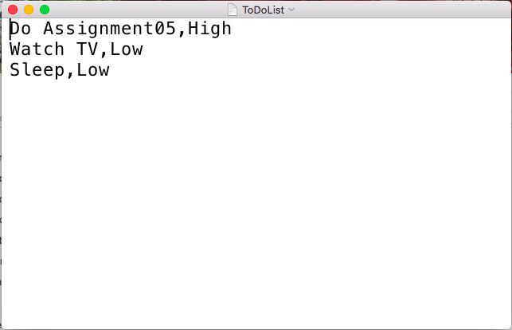

***Figure 1. Creating Text File with Data***

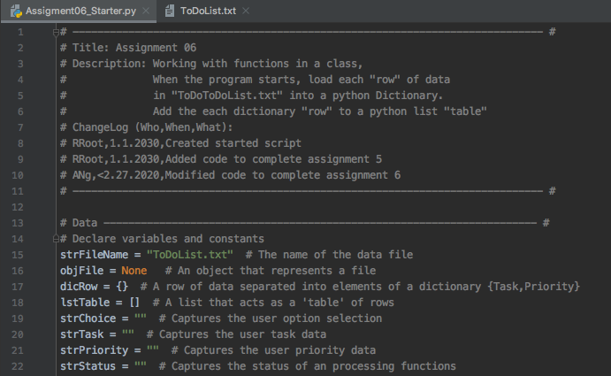

***Figure 2. Screen shot of the Variables and Constants in the Data Section***

## **#Processing**

“Classes are a way of grouping functions, variables, and constants” (Root, Randal. _Mod6PythonProgrammingNotes.pdf. p.18). In the script you can see that we will be working with two class of functions: Processor and IO. Processor is responsible for processing tasks and IO is responsible for input/out tasks (Figure 3). The starter script has the main code set up and I filled out the rest of the parts where there’s a label “ToDo: Add Code Here!”. Most of the task codes are from previous assignments such as adding data to the list, removing data from the list, and writing data to a file. In the processing section we are defining the functions, so they can be executed in the main body of script. Notice the variables within the functions are different from the variables in the data section. These variables are called local variables as they are in the function. It is best to keep the global variables (variables in the data section) different from the local variables.

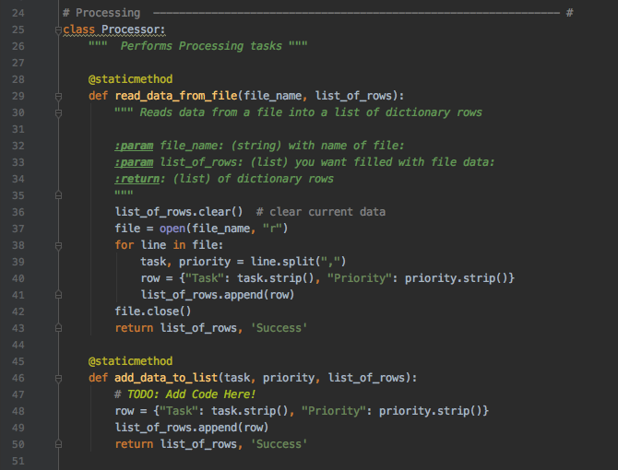

***Figure 3. Screen shot of the Class Processor in Processing Section of Script***

## **#Presentation**

In Figure 4, IO class performs the input/out tasks in the presentation section of the script. Similarly, we put the codes that is needed in the IO class as from the processing section. I added codes for input new task and priority and task to be removed.

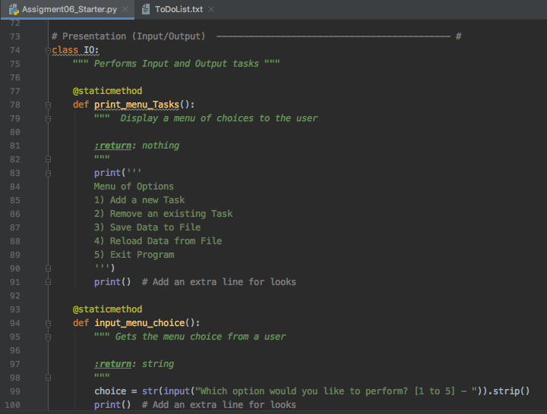

***Figure 4. Screen shot of the Class IO in the Presentation Section of the Script***

## **#Main Body of Script/Calling the Functions**

In the main body of script this is where we can execute the functions, which is also known as calling the functions. For this section we are writing out the function and the command.

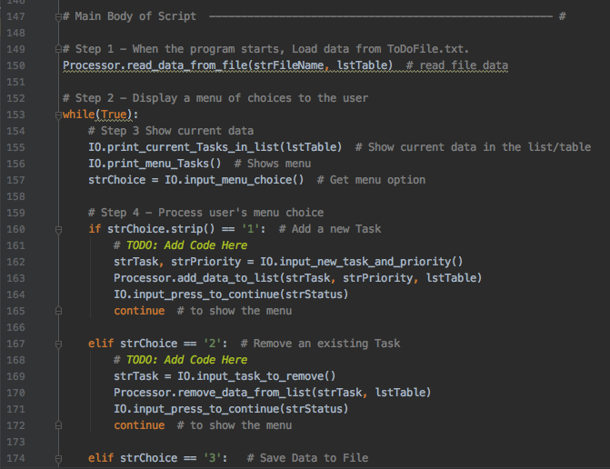

***Figure 5 Screen shot of the Main Body of the Script/Function Execution***

### **Summary**

In this assignment we are creating a script using functions and classes to start organizing a long complex script. From this assignment we begin to see the separation of concerns, functions and classes that help display the layers of data, processing, and presentation (input/output) in programming.

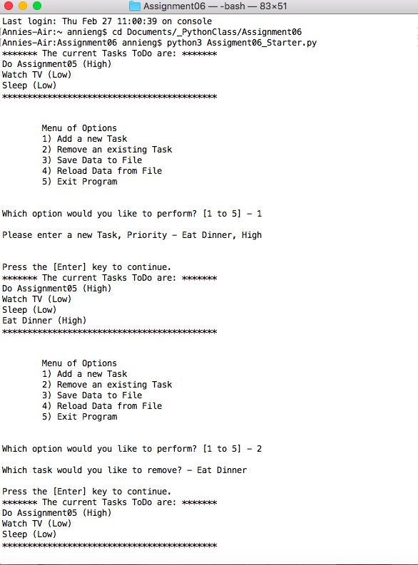

***Screen shot of Script in Terminal Mac OS***

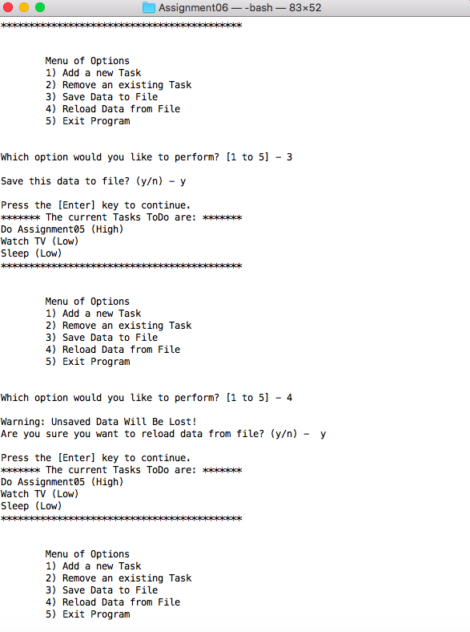

***Screen shot of Script in Terminal Mac OS (Continuation)***

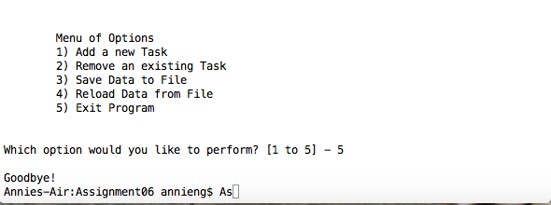

***Screen shot of Script in Terminal Mac OS (Continuation)***

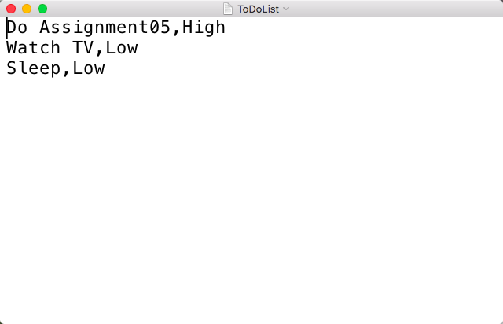

***Screen shot of Data Saved in Text File***

***Screen Shots of Script Running in PyCharm***

